

Cost Management Process©
For [Project Name]

Document Control

Document Information
© | Information
Document Id | [Document Management System #]
Document Owner | [Owner Name]
Issue Date | [Date]
Last Saved Date | [Date]
File Name | [Name]

Document History
Version | Issue Date | Changes
[1.0] | [Date] | [Section, Page(s) and Text Revised]

Document Approvals
Role | Name© | Signature | Date
Project Sponsor

Project Review Group

Project Manager©

Quality Manager
(if applicable)

Procurement Manager
(if applicable)

Communications Manager
(if applicable)

Project Office Manager
(if applicable)

Table of Contents

Template Guide 1
1 Cost Management Process 2
1.1 Overview 2
1.2 Document Expense 4
1.3 Approve Expense 4
1.4 Register Expense 5
2 Cost Management Roles 6
2.1 Project Staff Member 6
2.2 Project Administrator 6
2.3 Project Manager 6
3 Cost Management Documents 7
3.1 Expense Form 7
3.2 Expense Register 7

Template Guide
What is a Cost Management Process?

A Cost Management Process is a method by which costs (or expenses) incurred on the project are formally identified, approved and paid. Typical types of costs include:

- Labor costs (e.g. staff, external suppliers, contractors and consultants)
- Equipment costs (e.g. computers, furniture, building facilities, machinery and vehicles)
- Materials costs (e.g. stationery, consumables, building materials, water and power)
- Administration costs (e.g. legal, insurance, lending and accounting fees). ©

Cost Management is undertaken by completing the following processes:

- Document Expense Form
- Approve Expense Form
- Register Expense Form.

When to use a Cost Management Process

The budgeted (or expected) costs of the project will previously have been laid out in the Financial Management Plan, documented during the Planning phase of the project. The Cost Management Process is initiated after the Financial Plan has been approved and provides a formal process for the monitoring and control of the actual costs of the project, against that originally budgeted. Although the Cost Management Process is usually undertaken after the Financial Plan has been formally documented and the project is underway (i.e. during the ‘Execution’ phase of the project), costs should be formally tracked during all phases of the project. ©

If costs are not formally recorded, it may be difficult to accurately assess the total cost of the project and therefore become impossible to manage the project management constraints of time, cost and quality.

How to use this template
This document provides a guide on the topics usually included in a Cost Management Process. Sections may be added, removed or redefined at your leisure to meet your particular business circumstance. Example tables, diagrams and charts have been added (where suitable) to provide further guidance on how to complete each relevant section.

Cost Management Process

Overview
Describe the purpose of the Cost Management Process. For example:

The purpose of the Cost Management Process is to accurately record the actual costs (or expenses) which accrue during the project's lifecycle. Cost Management comprises 3 generic processes:

- Document Expense Form
- Approve Expense Form
- Register Expense Form. ©
Project costs are formally documented through the completion of Expense Forms. List the core principles involved in the completion and approval of Expense Forms. For example:

- The Project Manager will approve payment of a project expense, only if a valid expense form has been completed. Expense forms must be completed for ALL project expenses, including contractor, supplier, equipment, materials and administration costs. Staff salary costs are exempt as salary costs can be calculated from the timesheet information provided for the Project Manager on a regular basis
- Expense Forms should be completed weekly and submitted to the Project Manager for approval by the following Monday (for the prior week's entries). ©

The following diagram depicts the processes and procedures to be undertaken to identify, approve and pay project expenses. Where applicable, Cost Management Roles have also been identified:

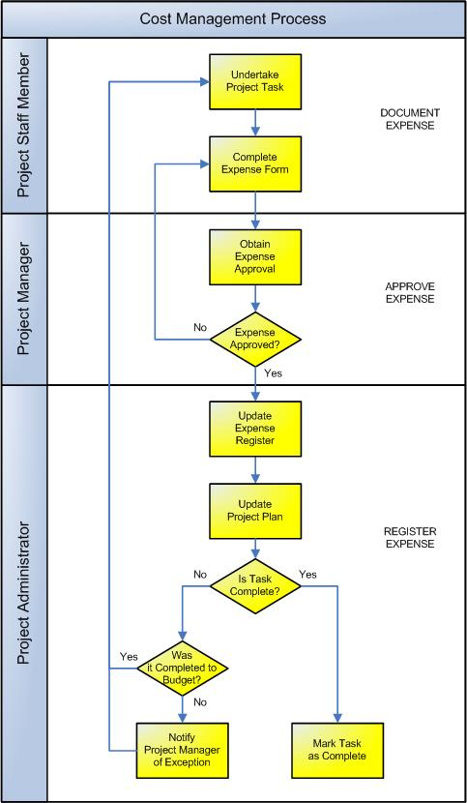

Document Expense
This process involves the capture of information relating to a cost (or expense) incurred on the project. The following procedures are undertaken:

Undertake Project Task
Costs are incurred on the project when undertaking project activities and tasks. It is therefore important to identify the project activity and task related to each cost incurred so that the total cost of undertaking project activities and tasks can be calculated.

Complete Expense Form
On a periodic basis (usually weekly), Expense Forms should be completed by:

- Members of the project who have had to incur project expenses personally
- Project Administrators, on behalf of external Suppliers who have issued Invoices for goods and services rendered
- Contractors allocated to the project for services provided. ©

Approve Expense
This process involves gaining the approval of the Project Manager to process the expense payment. The following procedures are undertaken:

Obtain Expense Form Approval
Completed Expense Forms should be forwarded to the Project Manager for review and approval. The Project Manager will then complete the following steps prior to approving each Expense Form:

Confirm that:

- The tasks for which the expense occurred are valid (as per the Project Plan)
- The expense was originally budgeted (as defined in the Financial Plan)
- Any unbudgeted expenditure is fair and reasonable and the Project Manager has the authority to authorize the unbudgeted expenditure. ©

Note. The Project Manager may have authority to approve only budgeted expenditure. Unbudgeted expenditure over a certain limit may require the approval of the Project Board or Sponsor.

Based on the above information, the Project Manager will:

- Approve the expense and forward it to the Project Administrator for payment or
- Request further information from the person submitting the form or
- Decline the expense and raise an issue with the person submitting the form.
Schedule Expense Payment
Following formal approval of the expense by the Project Manager, payment will be scheduled. It is typical to pay expenses in ‘batches’ to reduce the administrative workload in making expense payments and more effectively manage project cash-flow.

Register Expense
This process involves updating the Expense Register and Project Plan with the relevant information and notifying the Project Manager of any budget vs. actual expense exceptions. The following procedures are undertaken:

Update Expense Register
After the payment has been scheduled, the Expense Register should be updated to ensure that an accurate record of the approval and payment is kept. Although the register must be updated after the expense has been approved, the register should be updated throughout the process to ensure that the Project Manager is kept informed of the expense status at all phases in the expense approval cycle.

The Expense Register records the full details of all Expense Forms submitted, thereby enabling:
- The Project Plan to be updated with the expenses recorded against each task
- The cost of each staff member to be calculated and monitored throughout the project
- Monitoring of the actual expenditure vs. the budgeted expenditure throughout the project. ©

Update Project Plan
On a regular basis (typically weekly) the Project Plan is updated, with the total expenditure recorded against each project task as listed within the Expense Register. This enables the Project Administrator to:

- Produce a view of the overall cost of the project to date
- Identify any exceptions (e.g. instances where the actual expenditure exceeds the planned expenditure).

Notify Project Manager of Exception
The Project Administrator then provides the Project Manager with a copy of the updated Project Plan and identifies any expenditure deviations noted to date. It is then up to the Project Manager to take action, based on the extent of the deviation from plan. Examples of actions taken may include:

- Changing the individual / amount of resource allocated to the task
- Allocating additional funds to complete the task
- Requesting assistance from an external supplier to complete the task
- Raising a project issue for action by the Project Board / Sponsor. ©

Mark Task as Complete
Once each task is completed, the respective task within the Project Plan is marked as 100% complete and no further expenditure may be allocated to the task for the duration of the project.

Cost Management Roles

Define the roles and responsibilities for all resources involved with the request, approval and payment of expenses within the project. Note: The number and types of roles will depend on the size and complexity of the project. For instance, on a small project the Project Manager may fill the role of Project Administrator. Regardless of who actually fills each role, it is important to identify the generic expense responsibilities required to be undertaken on the project. Examples include:

Project Staff Member
The Project Staff Member is responsible for:

- Undertaking each delegated task to the best of his/her ability
- Completing regular Expense Forms to the level of detail requested
- Submitting Expense Forms to the Project Manager for approval
- Providing the Project Manager with further information surrounding the expense. ©

Project Administrator
The Project Administrator manages the day-to-day expense process by:

- Providing all staff with the Expense Form template for completion
- Ensuring that all Expense Forms supplied by project staff members are completed on time and to the required level of detail
- Completing Expense Forms for supplier invoices received
- Forwarding all Expense Forms to the Project Manager for approval
- Maintaining the Expense Register to ensure that all project expenditure information is accurate and up to date
- Entering summarized expense information into the Project Plan and identifying any exceptions for the Project Manager's attention
- Arranging payment of each expense once approved.

This role may also be undertaken by a Project Accountant, if available on the project.

Project Manager
The Project Manager has overall responsibility for the Cost Management Process, including:

- Ensuring that all staff are informed of the Cost Management Process, that they understand when Expense Forms need to be submitted, to whom and in how much detail
- Reviewing and approving all Expense Forms
- Drawing up action plans to address any deviations from plan
- Resolving all expense issues with staff members or suppliers and raising any critical expense-related issues with the Project Board / Sponsor for action. ©

Cost Management Documents

List any other documentation used to undertake the Cost Management Process within the project. For example:

Expense Form
An Expense Form is a document which is completed by a project member to request the payment of an expense on the project. Insert a template for the Expense Form here to show how expenses will be documented and approved on the project. (NB Refer to the Method123 ‘Expense Form’ template for a complete example).

Expense Register
The ‘Expense Register’ is the central log / database where all expense information is formally recorded for the project. Insert a template for the Expense Register here to show how expenses will be recorded on the project. (NB Refer to the Method123 ‘Expense Register’ template for a complete example).

